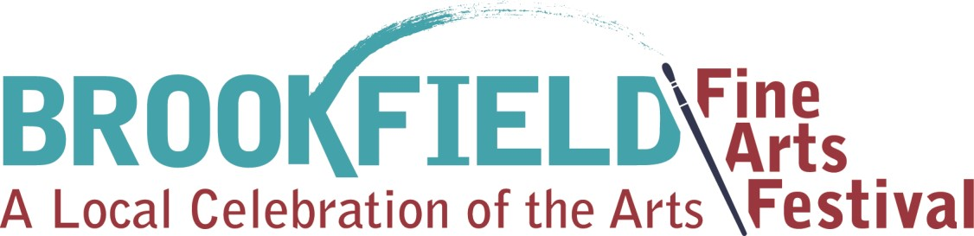

2019
Artist Application

When: Saturday September 21st, 2019
Time: 9am-4pm
Where: In Kiwanis Park 8820 Brookfield Ave. Brookfield Illinois 60513
Contact Person: Abby Snow 773.987.1151

Art Policies

All artwork must be handmade. Any artist selling work that is not handmade will not be accepted or will be asked to leave the art festival.

All artists must be 18 years old or older.

Each participating artist must apply & pay the appropriate fees to participate. If you are hosting another artist’s work in your tent or another artist who has not applied and paid appropriate fees you will both be asked to leave.

All applications must be turned in with a non-refundable $10 processing fee. Must be a check written out to Brookfield Chamber of Commerce.
All applications must be turned in with a separate $75 participation fee. Must be a check written out to the Brookfield Chamber of Commerce. Anyone who is not accepted into the art fest will have their $75 check returned to them by mail.

Continued.
Each artist must have a tent to set up their booth. Each application must be turned in with your tents fire certification. These can be found with your tent at the time of purchase or online from the company.

Special requests for set up, tent location, spacing cannot be guaranteed.

Each artist must include 2 photos of their art work.
Also include a photo of your typical booth or tent set up.

Each artist must also be able to provide us with high quality images of their art work either via email or to be accessed from their website or facebook page or instagram page. These are used to promote the art fest and artist via facebook and instgram. Photos can also be directly emailed to brookfieldfineartsfestival@gmail.com make sure you note who you are if you email the photos.

Each application must include the signed Village of Brookfield Liability waiver.

Please drop off or mail applications and fees to:
Brennan Massage & Spa
3700 Grand Blvd.
Brookfield, Il 60513
Attention: Abby Brennan/Art Fest

Applications must be submitted by Friday August 16th 2019.

It is asked that artist collect and distribute a poster and art festival post cards to promote the Brookfield Art Fest to their network of friends and family. Posters and post cards can be picked up at Brennan Massage & Spa. An email will be sent to all participating artist when posters and post cards are printed and ready.

It is asked that artist forward the Brookfield Art Fest promotional email to their social network.

It is asked that artist promote the Brookfield Art Fest to their Facebook friends.

Each artist will be given a 10x10 space for their tent and art work. If you need extra space you will be charged an additional $75 for the space.

Each tent must be weighed down with 200 pounds of weight. 50lbs a corner. This is to protect yourself and the community. You can find weights to purchase from tent manufacturers. Many artists make their own weights from PVC piping and sand. You can find examples online.
All tables displaying art work MUST be covered with a table cloth.

You will be able to begin setting up at 7:00 am. You will need to check in at the information table/tent. If an early set up the night before can be arranged we will make an announcement via email.

You must be set up for the festival by 8:45am.

You must stay for the entire art festival unless weather is determined severe.

You will have until 6:30pm to pack up and leave the art festival.
Please donate a work of art to our Brookfield Art Festival raffle. It is appreciated if donations have a value of $25 or more.

Parking:

All artists may unload their works of art, tents, and materials in the Village parking lot.
This will be close to your assigned artist space. Look for the Village Hall of Brookfield. 8820 Brookfield Ave.

Sponsored by the Brookfield Chamber of Commerce
Applications are due by Friday August 16th 2019

Name___________________________________________________________________

Mailing Address__________________________________________________________

Contact Number__________________________________________________________

Email address____________________________________________________________

Web Site________________________________________________________________

Facebook page and Instagram Page___________________________________________
_______________________________________________________________________

Please describe your style of art and the medium you work with.____________________

________________________________________________________________________

________________________________________________________________________

What is the average price of your art work?_____________________________________
Remember to include:

_____All applications must be turned in with a non-refundable $10 processing fee. Must be a check written out to Brookfield Chamber of Commerce.

_____All applications must be turned in with a separate $75 participation fee. Must be a check written out to the Brookfield Chamber of Commerce. Anyone who is not accepted into the art fest will have their $65 check returned to them by mail.

_____Each artist must include 2 photos of their art work.

_____If you have a photo of your booth please include as well.
_____Remember we need access to high quality photos of your work either emailed to brookfieldfineartsfestival@gmail.com or they should be accessible on you website, facebook page or Instagram page.

_____You have provided us with your website so we can access photos of your work or you have emailed high quality photos of your work to holly@... To be used in social medi marketing.

_____Each application must be turned in with your tents fire certification. These can be found with your tent at the time of purchase or online from the company.

_____Each application must include the signed Village of Brookfield Liability waiver.

Please donate a work of art to our Raffle!
(Donation sales help us continue to sponsor the Brookfield Art Fest and keep participation fees affordable. Please consider.)

Will you be donating a work of art for the raffle? Yes___________ No____________ If yes please bring your work of art to the raffle table Saturday morning.

